SRS DOCUMENT FOR SMART DRINK VENDING MACHINE
Developed by:
Dennis
Chun Ho
Titus
Matin

Table of Contents
Document Version 3
1. Purpose 4
1.1. Intended Audience 4
1.2. Intended Use 4
1.3. Scope 4
1.4. Definitions and Acronyms 4
2. Overall System Description 5
2.1. Use Case Diagrams 5
2.2. System Architecture 6
2.3. Functional Requirements 7
2.3.1. Start Up and Main Menu 7
2.3.2. Dispense Drinks 8
2.3.3. Remote Access 8
2.3.4. Refilling or adding stocks 9
2.3.5. Authentication Services (Online payment) 10
2.3.6. Online Payment 11
2.3.7. Physical Payment 12
2.3.8. Updating of stock manually 13
2.3.9. Selection of Collection or Physical order 14
2.4 Non-Functional Requirement 15
2.4.1 Power Management 15
2.4.2 Burglar Detection 16
2.4.3 Shaking of the vending machine 17
2.4.4 Math Quiz game 18
3. Software Architecture 19
3.1 Static Software Architecture 19

Document Version
No | Update | Name | Date | Version
1. | Initial version | Dennis, Chun Hoe, Titus, Matin | 9/6/25 | 1.0
2. | Modified SRS doc to make it align with our goals for sprint 2 | Chun Hoe | 22/7/25 | 2.0
3. | Modified SRS doc to align with goals for sprint 3 | Dennis Ho | 14/8/25 | 3.0

Purpose

Intended Audience
This SRS document describes the System Requirements and Software Design for a Smart Drink Vending Machine, and the target audience are System and Software Engineers working on the development of this project.

Intended Use
The SRS defines the overall System Architecture and Requirements as well as the Software Architecture and Design. This document also contains the definition of the System Requirements which shall be used as the input for System Test cases and Software Unit Test cases.

Scope
This Document consists of all our following implementations related to the minimum requirements of the smart drink vending machine, as well as additional implementations to enhance the experience with the vending machine.

Definitions and Acronyms

Acronym | Description
IR | Infra-Red
LED | Light Emitting Diode
NFC | Near Field Communication
SW | Software
HW | Hardware
RFID | Radio frequency identification
QR code | Quick response code

Overall System Description

Use Case Diagrams
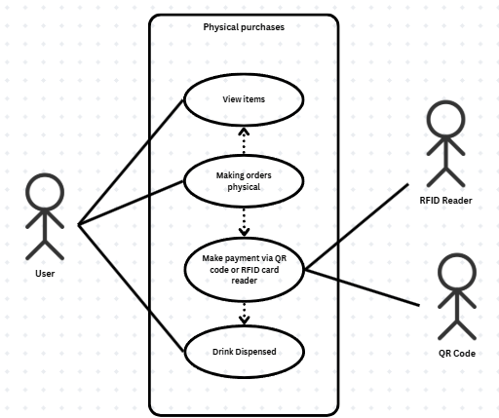
Figure 2.1.1: Use case diagram for physical purchases
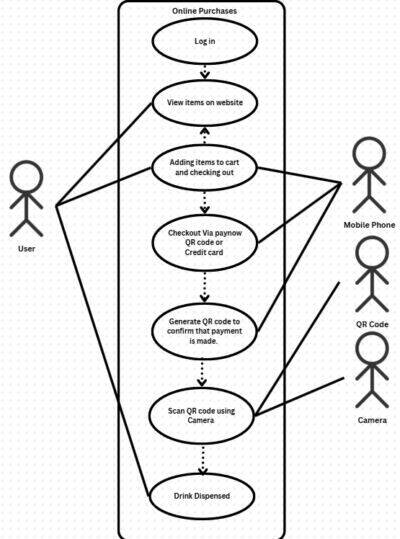
Figure 2.1.2: Use Case Diagram for online purchases

System Architecture

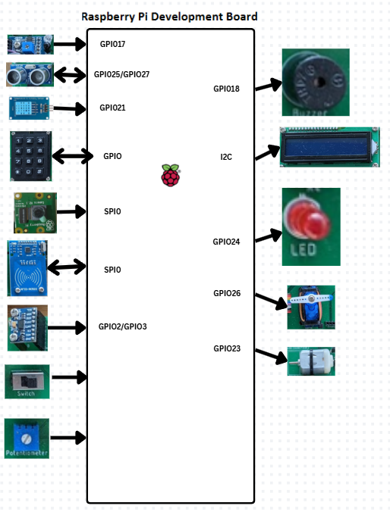
Figure 2.2: System Architecture of RPi

Functional Requirements

Start Up and Main Menu
Main menu to be listed when customer is near for them to select
REQ_ID | Requirement
REQ-01 | When customer is near the vending machine, machine enters High Power Mode state defined in the State Machine in REQ-21 and if REQ-51 picked, displays the following options on the LCD display. They should display the first 2 rows, followed by the consecutive 2 rows at an interval of 3 seconds:  - Turn Off  - Water Bottle - $0.50  - Coke - $2.00  - Sprite - $2.00  - Ayataka - $1.00  - Milk Tea - $3.00  - Coffee - $3.00  - A&W - $2.00  - Red Bull - $3.00  - Diet Coke - $2.00
REQ-02 | In the main menu defined in REQ-01, after option is selected, check if “*” is inputted. If inputted, proceed to REQ-03. Else, print the following message before ending the program:  “shutting down...”
REQ-31 | When the “#” button is clicked, the order is confirmed, and the users can proceed to payment as stated in REQ-15
REQ-03 | In the main menu defined in REQ-01, if the option “0. Turn Off” is selected, the  LCD should display the following text ‘Shutting down’ for 1 seconds and then turn off the LCD display and back light and enter the Low Power Mode state defined in the State Machine in REQ-24.

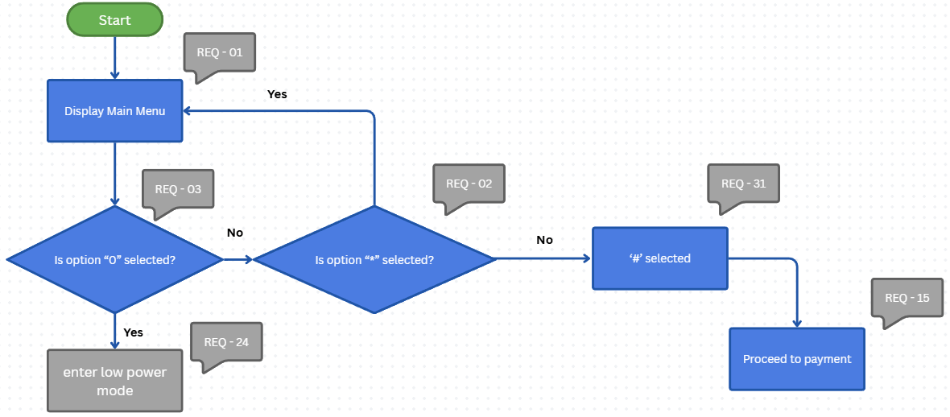

Dispense Drinks
Drinks dispensed according to number inputted by user
REQ_ID | Requirement
REQ-04 | If payment is made, the DC Motor will be activated for 5 seconds to stimulate the drink dispensing.

Remote Access
The vending machine supports remote access, allowing technicians to monitor the environment setting of the vending machine, and notify the technician in an event of a system malfunction.

REQ_ID | Requirement
REQ-05 | Vending machine continues to monitor temperature and humidity to ensure optimal conditions where drinks are stored.
REQ-06 | The system shall compare vending machine temperature readings with predefined thresholds (e.g., 2°C–8°C for cold drinks).
REQ-07 | If the vending machine readings exceed acceptable limits, the system shall automatically generate an alert to the technician via email.
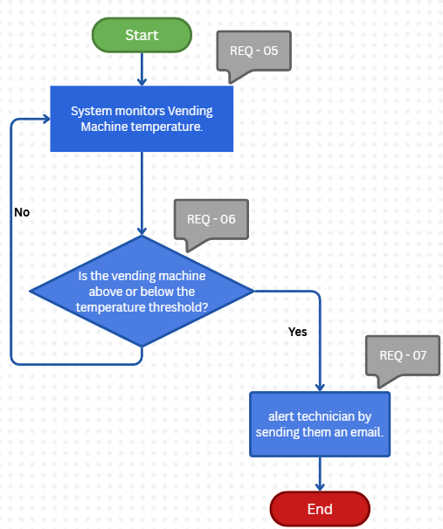

Refilling or adding stocks
To refill the stocks of the items, using the website
REQ_ID | Requirement
REQ-35 | The website should check if the user that has logged in is a valid staff
REQ-36 | If the user is a valid staff, then it should give the staff the option of add drinks or update drinks
REQ-37 | If update drink is selected, the user can select the drink to update and update the drinks accordingly
REQ-38 | If add drink is selected, the user can enter the details of the drink and upload an image of the drink, and it should be saved in the database

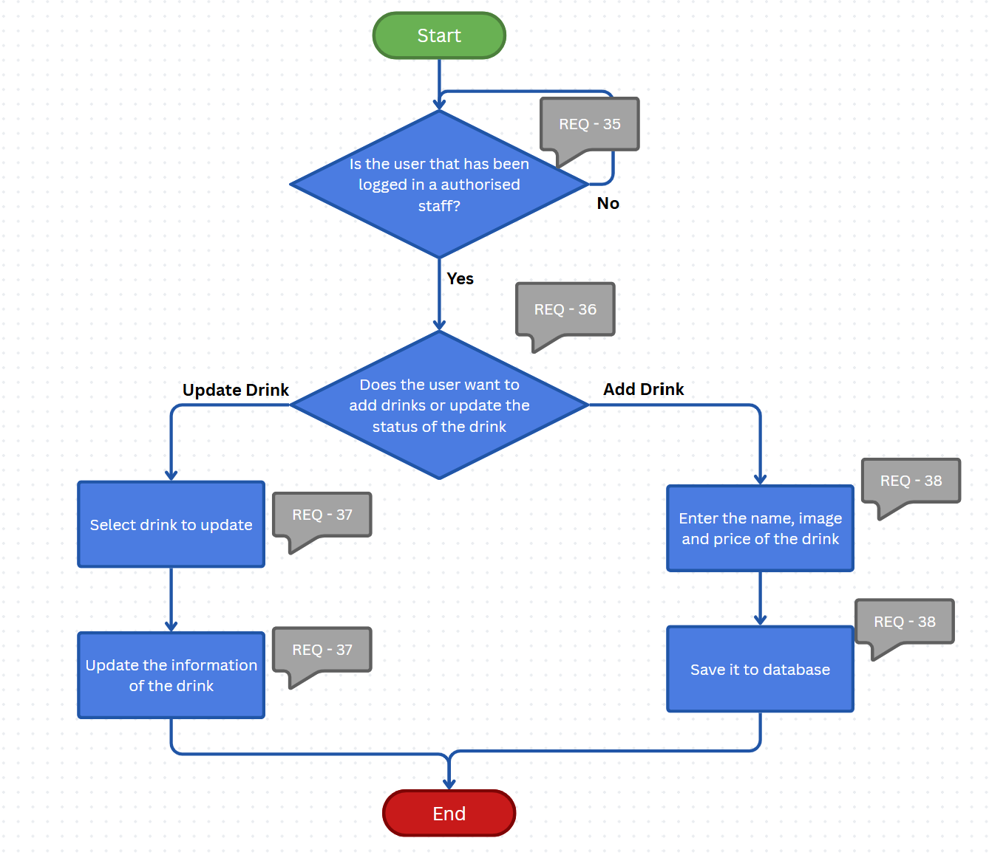

Authentication Services (Online payment)
To verify if QR code provided after online payment is Valid.
REQ_ID | Requirement
REQ-09 | Camera will detect if QR code is valid
REQ-10 | If QR code is invalid, A message will be displayed for users to try again.

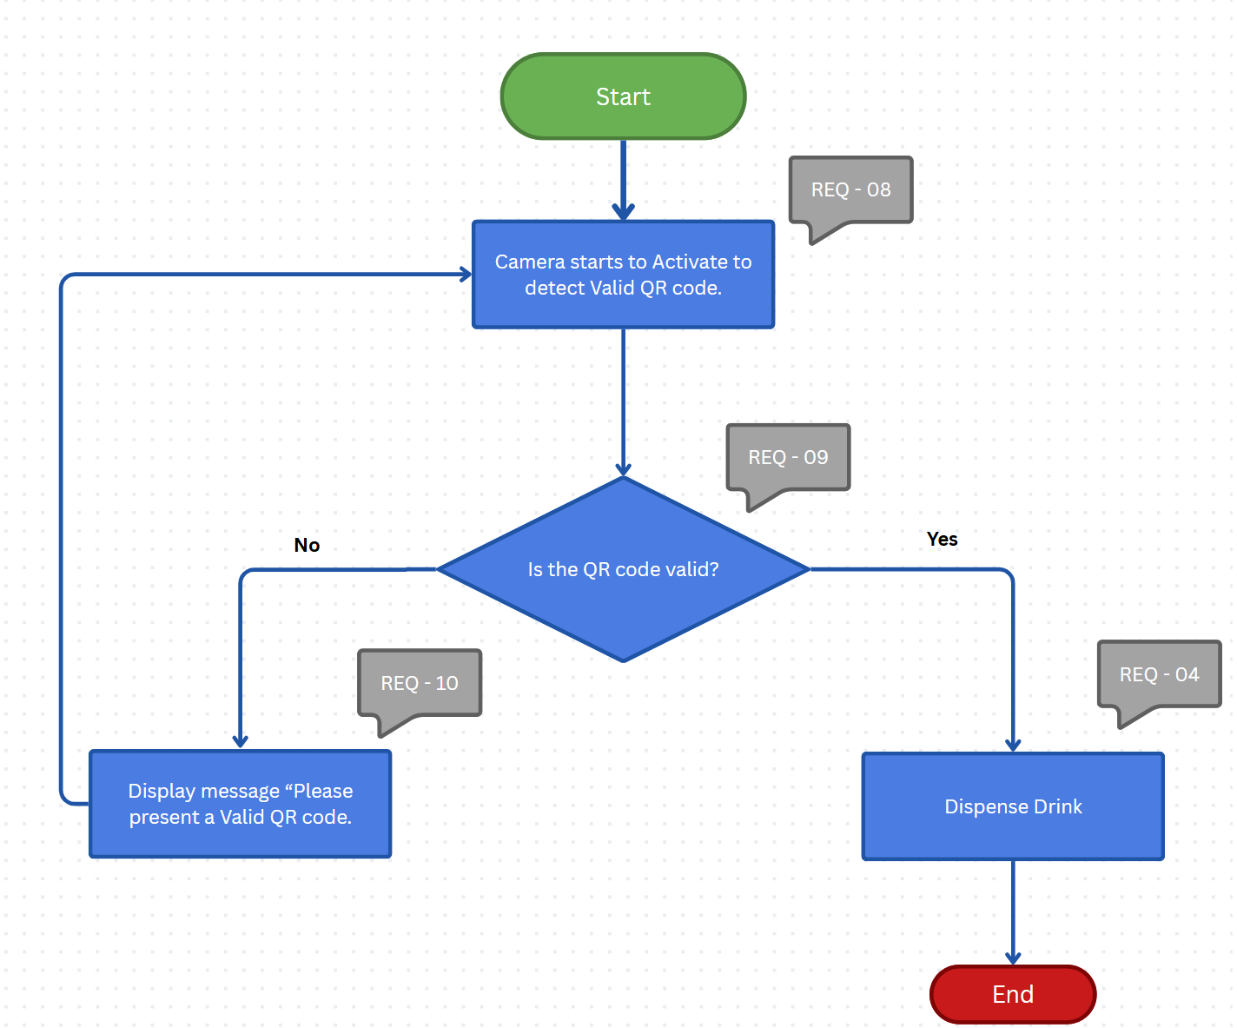

Online Payment
For customers to make payment via Paynow when purchasing their drink online
REQ_ID | Requirement
REQ-11 | After drink is selected, the website will generate a Paynow QR code for user to scan and pay
REQ-12 | Website will check if payment is successful
REQ-13 | If payment unsuccessful, machine will display “Payment unsuccessful” and will prompt customer to scan QR code again
REQ-14 | If payment is successful, machine will display “Payment successful” and a QR code for Authentication will be displayed for the customer. Users will then go to vending machine and select option ‘2’ and # as seen from REQ-52. They will scan the authentication QR code and drinks will dispense.
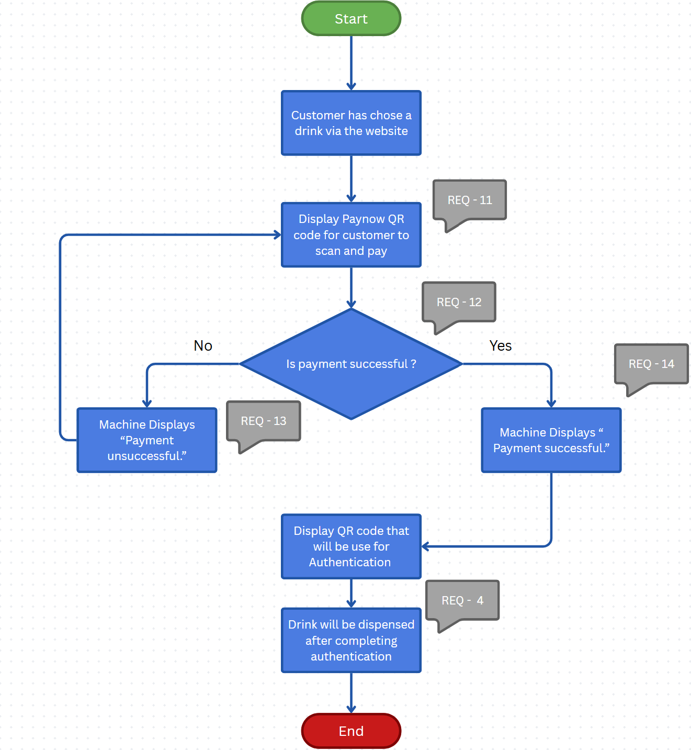

Physical Payment
For customers to make payment via card or QR code when purchasing their drink at the vending machine
REQ_ID | Requirement
REQ-15 | Once customer has chosen a drink, vending machine will prompt customer on LCD to make payment via card or QR code.
REQ-39 | QR code displayed for payment
REQ-40 | Display message to prompt user to make payment
REQ-16 | RFID card reader will be used to scan customer's card
REQ-17 | Vending machine will check if payment is successful
REQ-18 | If payment is unsuccessful, it will display “Payment unsuccessful” and prompt customers to retry the payment
REQ-19 | If payment is successful, it will display “Payment successful”

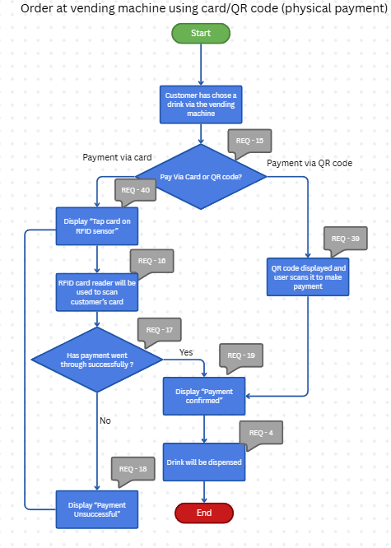

Updating of stock manually
REQ_ID | Requirement
REQ-45 | When switch is flipped (logic 1), goes to admin mode
REQ-46 | Admin will be prompted to key in code
REQ-47 | When code is keyed in correctly, grant access and user can change stock count.
REQ-48 | When code is keyed in wrongly, user will be prompted to key in code again.
For administrators to edit stock count during restocking.
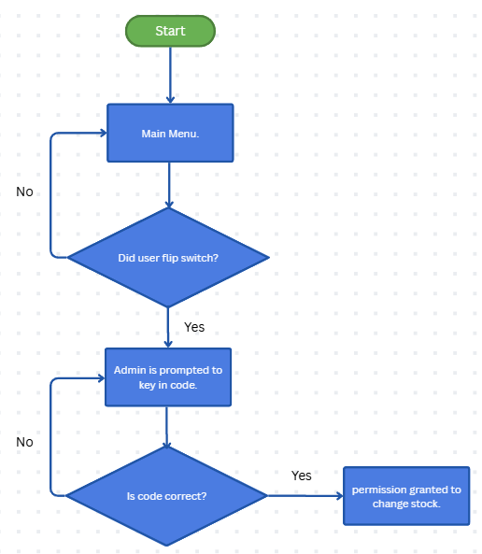

Selection of Collection or Physical order
For users to select if they have ordered drinks online or want to purchase one physically
REQ_ID | Requirement
REQ-49 | Menu Displays Buy ‘1’ and collection ‘2’ option
REQ-50 | When user selects 1 on keypad, select # and it will go to user menu
REQ-51 | When User selects 2 on keypad, select # and it will go to collection phase.

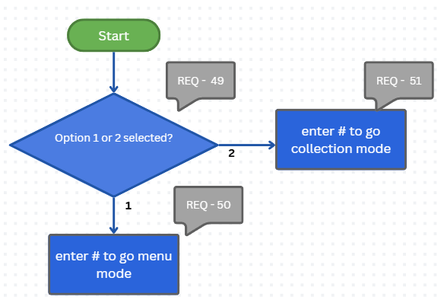

Non-Functional Requirement

2.4.1 Power Management
The vending machine shall manage its power efficiently to ensure operational stability and safety during both active use and idle periods, promoting sustainability of the machine.
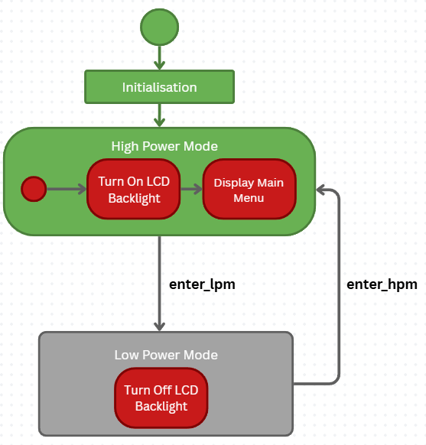

REQ_ID | Requirement
REQ-20 | ‘enter_hpm' Trigger Condition 1  - When a key in the keypad is pressed
REQ-21 | 'enter_hpm” Trigger Condition 2  - When the ultrasound sensor detects someone nearby
REQ-22 | ‘enter_lpm' Trigger Condition 1  - When the keypad has been inactive for 3 minutes, and it is not dispensing anything
REQ-23 | 'enter_lpm” Trigger Condition 2  - When the ultrasound sensor does for detect anything within 10 cm of range for 3 minutes
REQ-24 | 'enter_lpm” Trigger Condition 3  When the option ‘Power off’(0) is selected from the main menu
REQ - 41 | ‘enter_lpm” Trigger Condition 4  - After one ordering cycle and user doesn’t want to play math quiz game

Burglar Detection
The vending machine shall include a burglar detection mechanism to safeguard against unauthorised access and tampering

REQ_ID | Requirement
REQ-25 | The IR sensor is to detect any motion. If there is any motion, then it will indicate True for a 'door_open’ variable
REQ-26 | System is to check if payment has been made
REQ-27 | System is to check if the user is an authorised staff, as indicated in the RFID Reader
REQ-28 | If there is motion detected, and payment has not been made, and the user is unauthorised personnel, then it will save a snapshot of the burglar
REQ-29 | If there is motion detected, and payment has not been made, and the user is unauthorised personnel, then it will ring the buzzer for 10 seconds
REQ-30 | If there is motion detected, and payment has not been made, and the user is an unauthorised personnel, then it will send a notification and image of the burglar to authorized personnel using a telegram bot
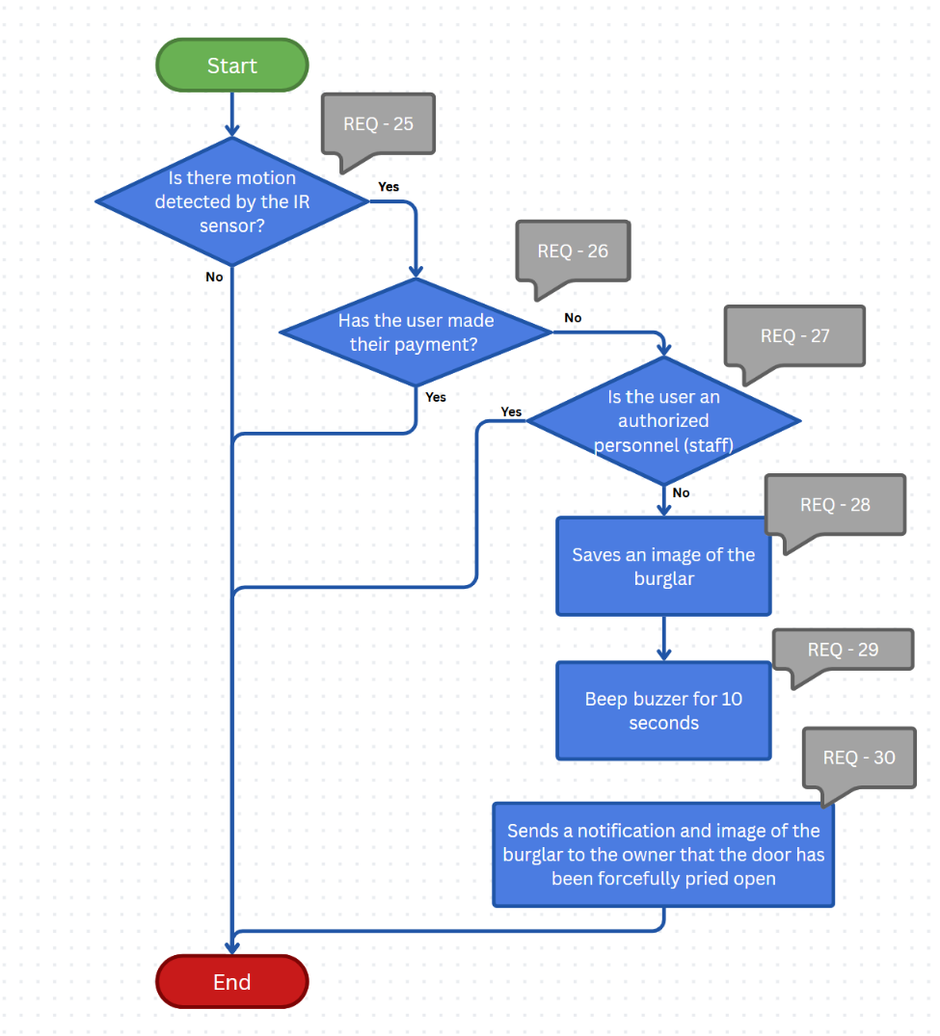

Shaking of the vending machine
The vending machine shall include a shaking detection mechanism to safeguard against unauthorised attempts to destroy the machine
REQ_ID | Requirement
REQ-32 | The accelerometer is used to detect if there is any violent shaking to the machine.
REQ-33 | If there is any violent shaking detected by the vending machine, it will ring the buzzer for 5 seconds and continue detecting if there is any shaking
REQ-34 | It will alert the technicians if there is any violent shaking
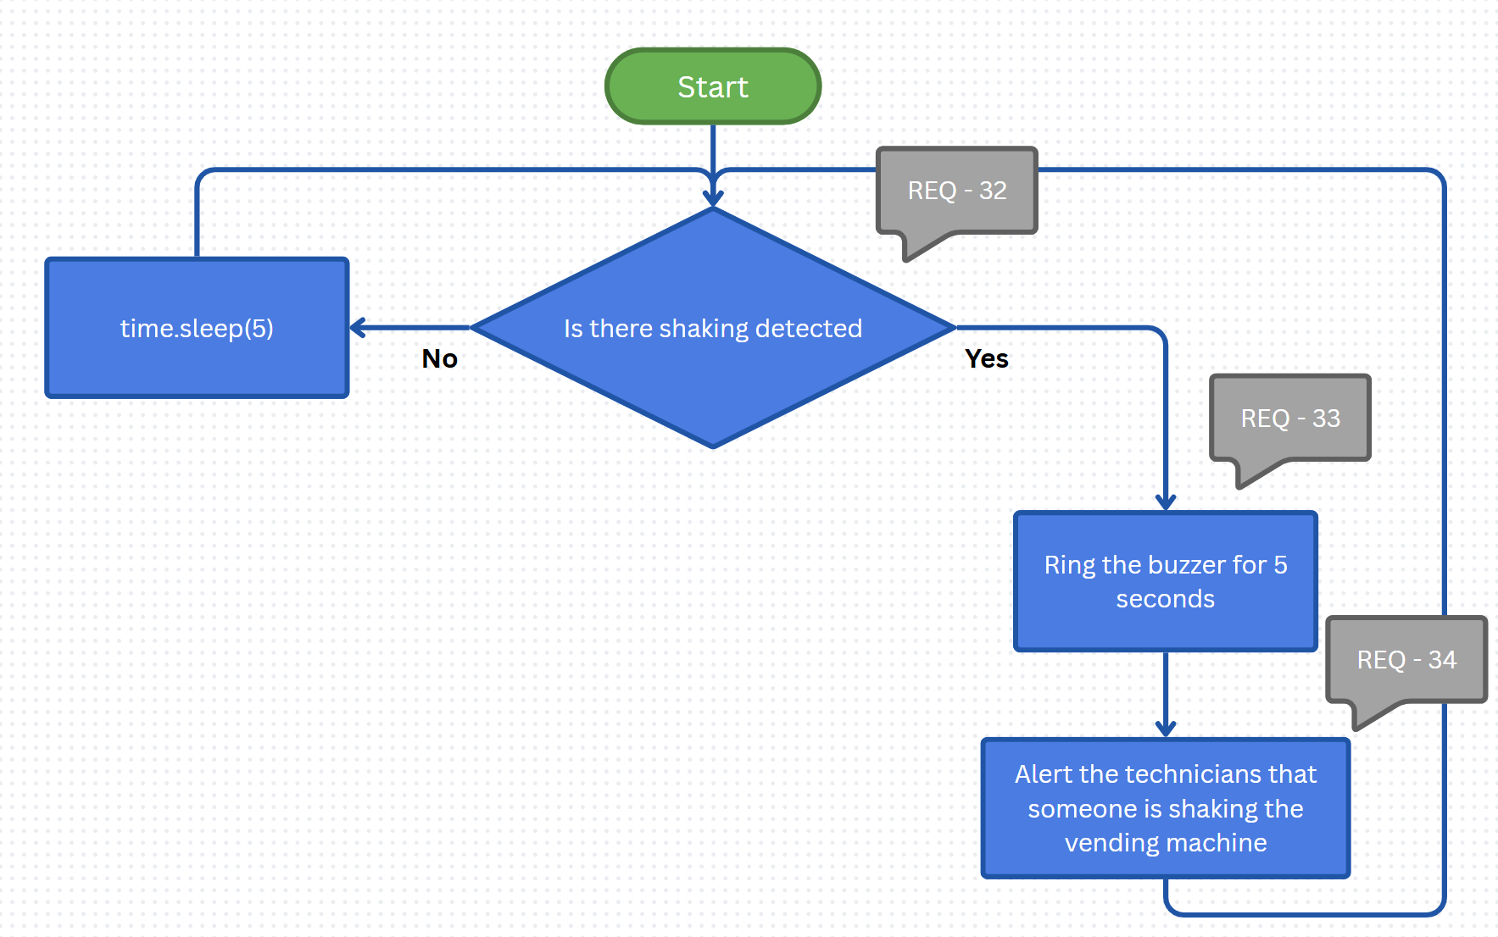

Math Quiz game
The vending machine shall include a minigame to enhance user experience and add a ‘fun factor’ to it
REQ_ID | Requirement
REQ-42 | User will be prompted if they want to play a minigame
REQ-41 | If user says no, do REQ-41
REQ-43 | If user says yes, Show questions.
REQ-41 | If user gets a question wrong, end game and do REQ-41
REQ-44 | If user gets all question correct, dispense a drink.

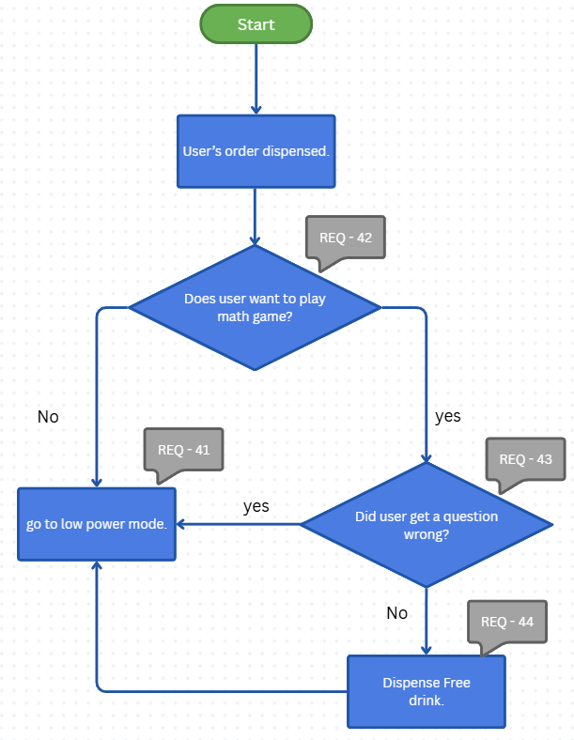

Software Architecture

Static Software Architecture

The Software Architecture defines the various Software Components that are developed to realize the implementation of the system requirements.

